Nome:___________________________ DATA: ____/___/____
ATIVIDADES AEE EDUCAÇÃO INFANTIL
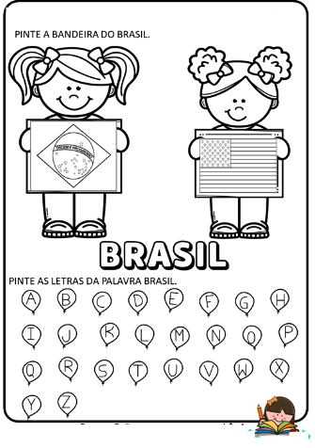
SUGESTÕES DE LINKS:
https://www.youtube.com/watch?v=_t-0hIOiEm4
https://www.youtube.com/watch?v=H0DELGLAi1w

NOME:___________________________ DATA: ____/___/____
ATIVIDADES AEE ENSINO FUNDAMENTAL I

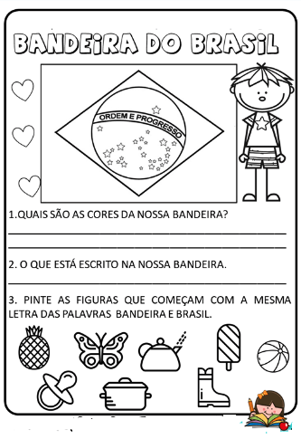
SUGESTÕES DE LINKS:
https://www.youtube.com/watch?v=_t-0hIOiEm4
https://www.youtube.com/watch?v=H0DELGLAi1w

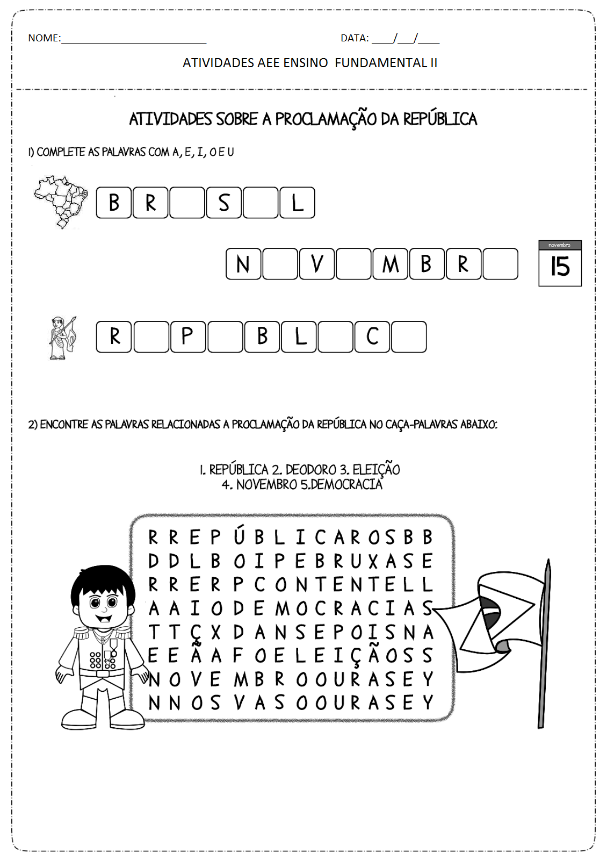
SUGESTÕES DE LINKS:
https://www.youtube.com/watch?v=_t-0hIOiEm4
https://www.youtube.com/watch?v=H0DELGLAi1w

