Nome:___________________________ DATA: ____/___/____
ATIVIDADES AEE EDUCAÇÃO INFANTIL
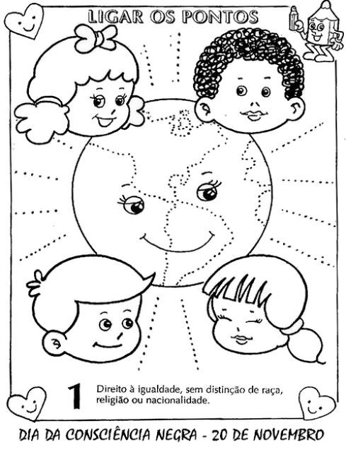
SUGESTÕES DE LINKS:https://www.youtube.com/watch?v=u3Yvyurymac
https://www.youtube.com/watch?v=61O2aI8pZ_A&app=desktop

Nome:___________________________ DATA: ____/___/____
ATIVIDADES AEE ENSINO FUNDAMENTAL I
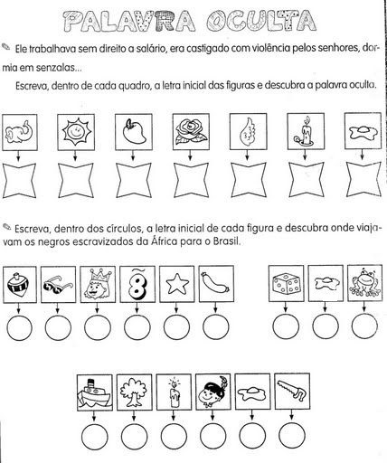
SUGESTÕES DE LINKS:https://www.youtube.com/watch?v=u3Yvyurymac
https://www.youtube.com/watch?v=61O2aI8pZ_A&app=desktop

Nome:___________________________ DATA: ____/___/____
ATIVIDADES AEE ENSINO FUNDAMENTAL II
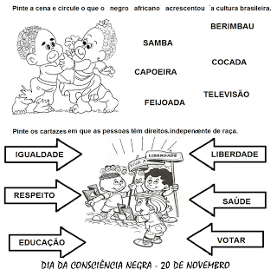
SUGESTÕES DE LINKS:https://www.youtube.com/watch?v=u3Yvyurymac
https://www.youtube.com/watch?v=61O2aI8pZ_A&app=desktop

