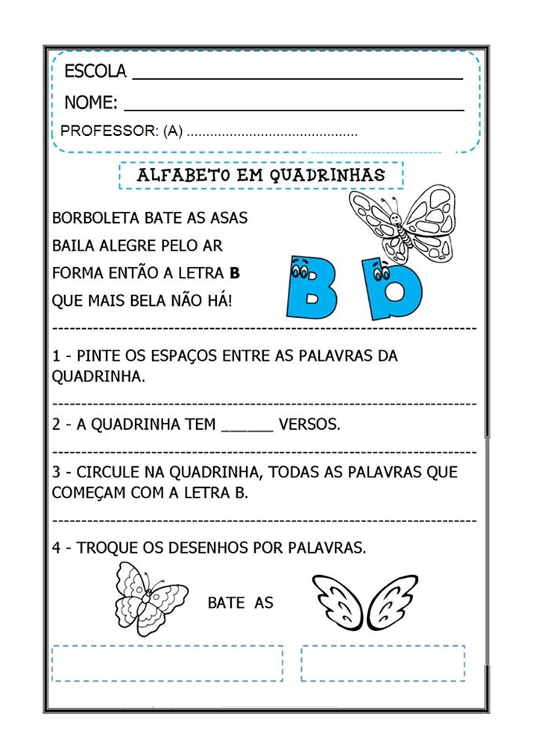

EMEFEI ______________________________________________
NOME:___________________________________________
PROFESSOR:______________________________ANO:_________
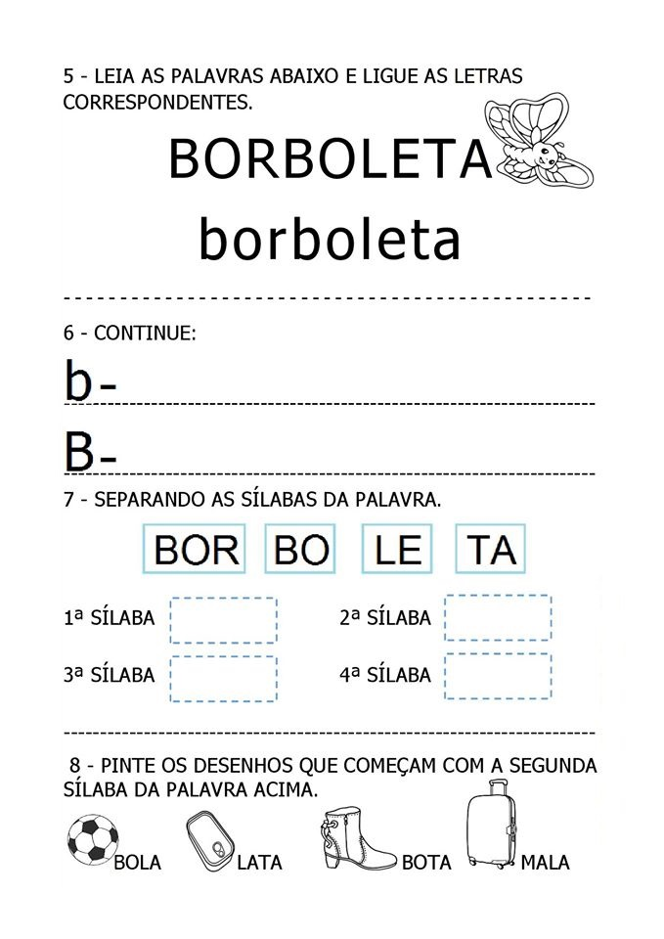
EMEFEI __________________________________________
NOME:____________________________________________
PROFESSOR:______________________________ANO:________
