EMEFEI ______________________________________________
NOME: ______________________________________________
PROFESSORA: ___________________________________ 3°ANO
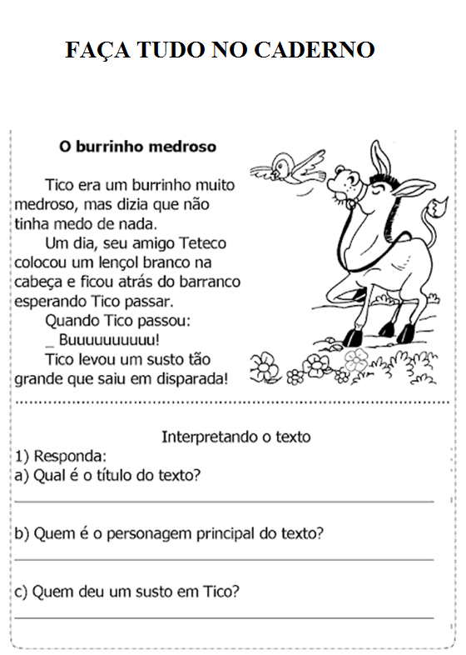
EMEFEI ______________________________________________
NOME: ______________________________________________
PROFESSORA: ___________________________________ 3°ANO
