ESCOLA ________________________________________DATA:_____/_____/_____
PROF:______________________________________________TURMA:___________NOME:_______________________________________________________________
PREPOSITIONS

IN- ON -UNDER

Observe:
There is a dog in the box .
The book is on the desk .
There is a cat under the table .

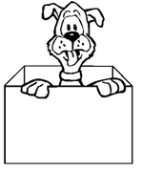
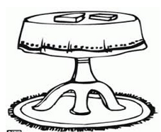
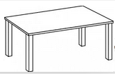

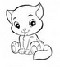

1.Observe the pictures and complete with in, on, under.
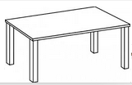
a.There is a Key________ the table.

b.There is a boy ______the plane.

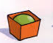

c.There is a ball_____ the box.

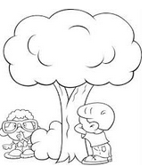
d.There are boys _______the tree.

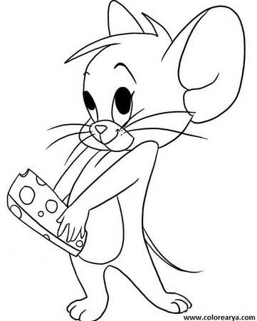

2.Observe the pictures and answer.
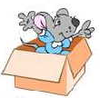
a.Where is the mouse?
It is ____the box.
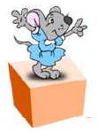

b.Where is the mouse?
It is_____the box.

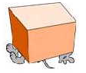

c.Where is the mouse?
It is_____the box.
3.Observe as imagens a assinale na opção correta.
a)in
b)on
c)under
a)in
b)on
c)under
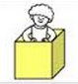 | a)in  b)on  c)under
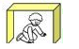 | a)in  b)on  c)under
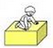 | a)in  b)on  c)under
a)in
b)on
c)under

